Chapter 13, Solution 70.

In the ideal transformer circuit shown in Fig. 13.133, determine the average power delivered to the load.

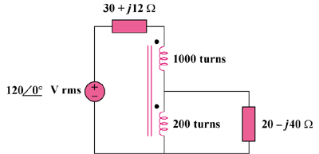

Figure 13.133
For Prob. 13.70.

Solution

This is a step-down transformer.

20 – j40

30 + j12

120∠0°

+
−

+

v₁

−

+

v₂

−

I₂

I₁

I₁/I₂ = N₂/(N₁ + N₂) = 200/1200 = 1/6, or I₁ = I₂/6 (1)

v₁/v₂ = (N₂ + N₂)/N₂ = 6, or v₁ = 6v₂ (2)

For the primary loop, 120 = (30 + j12)I₁ + v₁ (3)

For the secondary loop, v₂ = (20 – j40)I₂ (4)

Substituting (1) and (2) into (3),

120 = (30 + j12)( I₂/6) + 6v₂

and substituting (4) into this yields

120 = (49 – j38)I₂ or I₂ = 1.935∠37.79°

p = |I₂|²(20) = 74.9 watts.

